

Department of Mechanical Engineering

EMCH 368
MECHATRONICS

Lab 02
Sensors

Last Edited: 6/23/2024 by T. Russo

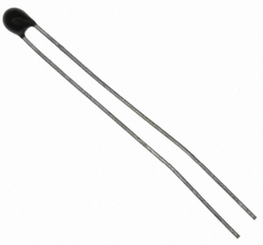
The thermistor included in the kit is a temperature sensitive resistor. This component’s resistance changes based on the temperature it senses. It has two pins that can either be wired to voltage or ground. The resistance of the thermistor decreases as the temperature increases, which can be measured by the microcontroller’s analog pins.

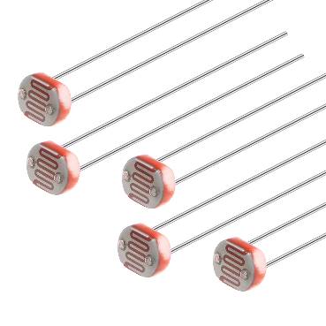
Photoresistors are components that change resistance based on the quantity of light they absorb. By connecting one end to the power bus, and the other to the ground with a resistor and a wire to an analog pin, you can measure the change in current by checking the voltage on the pin.

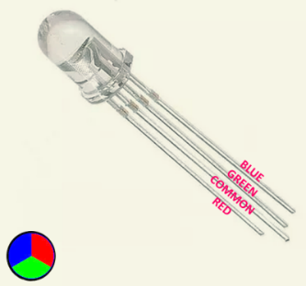
This LED with 4 legs is a common cathode RBG LED. The LED has separated red, green, and blue elements inside as well as a common ground leg. By varying the voltage between each color’s pin, the LED can output different amounts of light of each color. For our eyes, this can create a wide spectrum of colors despite there only being 3 different LEDs in this component. Note the LED orientation so that the correct lead goes to the corresponding pins. This is important for the program in Exercise 2. The lead labeled ‘R’ is red, the lead labeled ‘B’ is blue, the lead labeled ‘G’ is green, and the lead labeled ‘-' is ground.
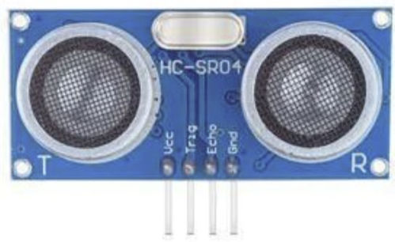
This is an ultrasonic sensor that can measure distance by emitting ultrasonic waves and measuring the time it takes to bounce back. It has four pins: VCC (power), GND, TRIG (trigger), and ECHO (echo). The TRIG pin sends out the pulse, and the ECHO pin receives the pulse that bounces back. By measuring the time, it takes to bounce back, the distance can be calculated.

Exercise 1: Creating a Circuit that Responds to Your Body Heat
Have you ever wondered how a thermometer takes information from the environment and translates that to a number on a screen? In this exercise, we will be creating something similar. Even though the ELEEGO is a digital tool, it is possible for it to get information from analog sensors to measure things like temperature or light. To do this, you’ll take advantage of the microcontroller’s built-in Analog-to-Digital Converter (ADC). Analog in pins A0-A5 can report back a value between 0-1023, which maps to a range from 0V to 5V read from the input pins.

Your goal is to create a circuit that meets the following criteria:
- Use a thermistor to gather temperature information from the environment
- Include at least 3 LEDs. For every increase of 2 degrees Celsius from room temperature, turn on an LED.
- As the temperature reading on the sensor returns to room temperature, have the corresponding LEDs turn back off
- Use the Serial Monitor to create a live report of the temperature reading.
Materials:
- 1 set of long red and black jumper wires
- 1 thermistor
- 4 220-ohm resistors
- 1 blue LED
- 1 red LED
- 1 green LED

Building the Circuit:
- Connect a red wire to the 5V pin and put the other end in one of the long (+) bus lines in the breadboard.
- Connect a black wire to the ground pin to the (-) bus line on the breadboard.
- Place the thermistor on the breadboard with each pin on a separate row of the prototyping area.
- Connect one pin to the ground using a 220-ohm resistor. Connect the other pin to power.
- Also connect the side that is grounded to an analog pin.
- Place 3 LEDs on your breadboard. Connect each of the anodes (long legs) to digital pins. Connect the cathodes (short legs) to the ground (-) bus with 220-ohm resistors.
- Connect USB power to the microcontroller

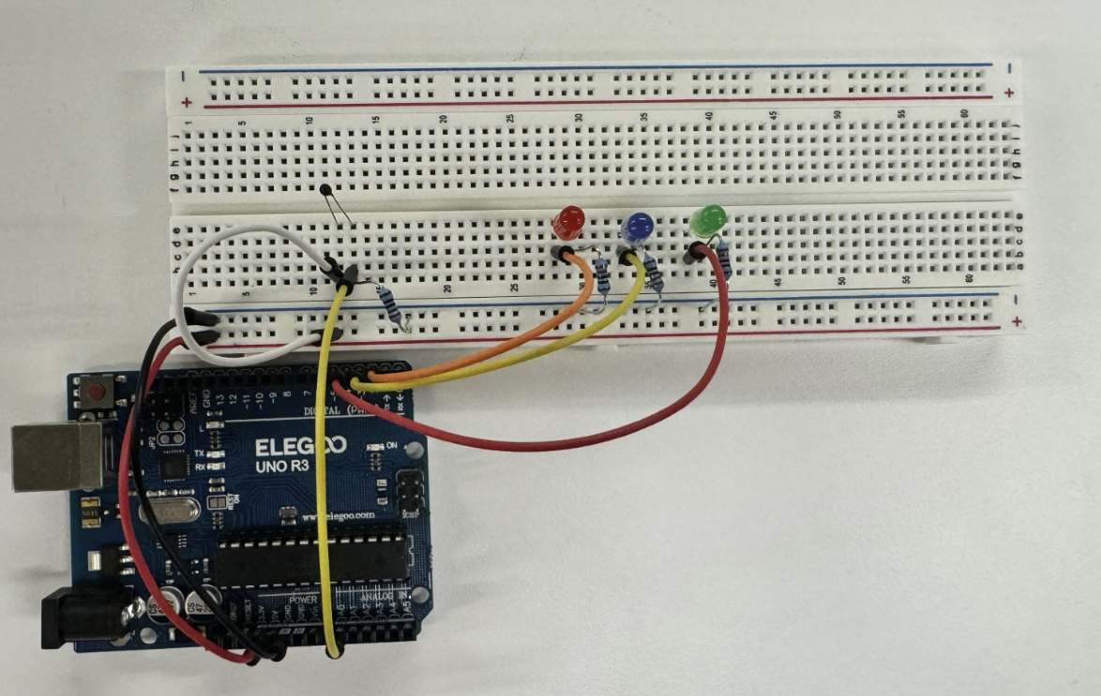
Exercise 1 Circuit

Writing the Program:
In this example, pin A0 is used to read the voltage value coming from the thermistor. The float resist variable is used to hold the voltage recorded.
The serial.begin(9600) command opens serial communication between the microcontroller and programming computer, and sets the transmission speed to 9600 baud. The for loop is used to quickly set the digital pins connected to the LEDs to outputs and subsequently set each pin to LOW (LEDs are OFF) before running the program’s body. The for loop takes three arguments: the initialization, the condition, and the update. In this case, we create a temporary variable called pinNumber that acts as a counter and that we initialize as 2. This tells the for loop to begin by writing pin 2 on the board. The condition is pinNumber < 5. This means that the loop should continue to run while the pinNumber is less than 5. The condition of a for loop is checked before each cycle to determine if the loop should run again. The update is pinNumber++. After each run of the loop, the update increments the counter variable, and the updated counter variable is checked against the condition. Without this update, the for loop would only be setting the initial pinNumber to LOW repeatedly, resulting in an infinite loop which is not desired in this case.
The reason we use a for loop here is because we are doing an action repeatedly i.e. setting these pins to outputs and LOW. We could write code to do this for each pin individually but imagine if we had 50 pins to assign a mode to. This would take forever! So, a for loop is great to do these repetitive actions.
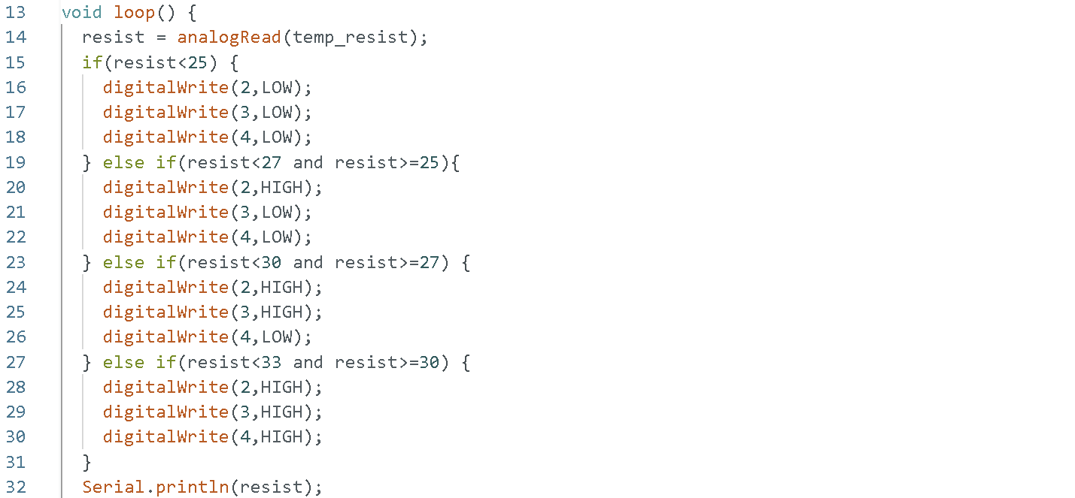
This block of code updates the LED outputs depending on the reading from the thermistor. Since this is all in the void loop(), this section of code will be run over and over again, constantly updating the LEDs to reflect the temperature reading. At the end is “Serial.println()” which will print the value recorded for resist inside of the Serial monitor. Remember that serial.print() is great for trouble shooting such as seeing what value is being reported from a variable or checking to see if an if statement is running by telling the microcontroller to send a message during its activation.
Introduce a small 1 millisecond delay at the end of the void loop(). The ADC can only read so fast, and if the values appear erratic if they are read too frequently.

Exercise 2: Increasing Brightness of an RGB LED with Light
You have already experimented with blinking LEDs, but what about fading them? You might expect that it is just a matter of providing less voltage to an LED to get a more faded response. However, the ELEEGO cannot vary the output voltage on its pins. It can only output 5V. To get this fading effect, you will need to use a technique called Pulse Width Modulation (PWN). PWM rapidly turns the output pin between HIGH and LOW over a fixed time period. The change is so quick; the human eye cannot see the flicker. The percentage of time a pin is HIGH in a period is called duty cycle, and the higher the duty cycle is, the brighter the LED appears. NOTE: The ELEEGO has six pins set aside for PWM: digital pins 3, 5, 6, 9, 10, and 11.
Your goal is to create a circuit with the following criteria:
- Use 1 photoresistor
- Use the input from the photoresistor using the map() function to get values from 0 to 255
- The color change of the RGB LED should be smooth

Materials:
- 1 set of long red and black jumper wires
- 1 photoresistor
- 1 RGB LED
- 4 220-ohm resistors

Building the Circuit:
- Remove USB power before tampering with the circuit
- Clear all the components from the breadboard except the lines to the power and ground buses.
- Wire your breadboard so that you receive power from both (+) buses.
- Wire one leg of the photoresistor to the power bus, ground the other leg with a 220-ohm resistor and wire this leg to Analog pin A1.
- Place the RGB LED onto the right-side breadboard. The longest pin is the ground pin. Ground it to the (-) bus.
- Note which color LED the other legs are for in the figure at the top of the document. Connect each of the other pins to digital pins 9, 10, and 11 respectively, each with a 220-ohm resistor
- Plug in USB power and upload your code.
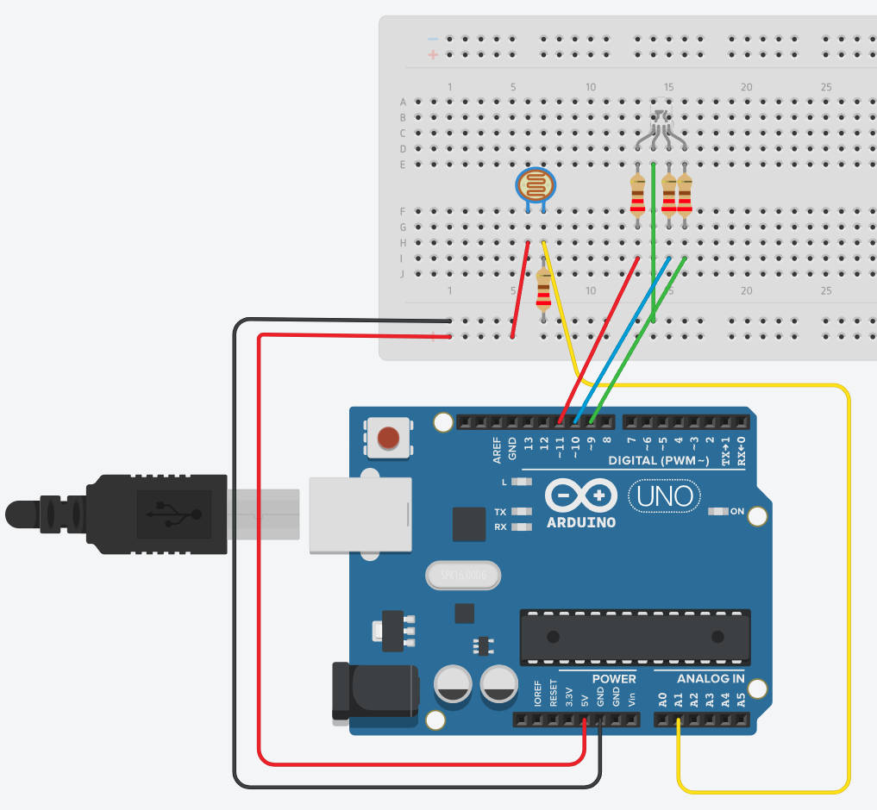

Exercise 2 Circuit

Writing the Code:

Set up constants for the pins you are using for input and output, so you can keep track of which sensor pairs with which color on the LED. Use const for the datatype. Initialize variables for the incoming sensor values. You can use the int data type for the variable.
In the setup, begin serial communication at 9600 baud. Just like in the previous exercise, you will use this to see the values of the sensors in the serial monitor. Additionally, you will be able to see the mapped values used to fade the LED. Define the digital pins with the LED’s connected as outputs. You can use the variable name for the digital pin instead of the number since it was declared in the beginning. At this point, you should not need to see the code to do this.
analogRead() is used again in this program this time to determine the amount of light shining on each phototransistor. The values 0 and 400 were chosen due to output of around 400 when a flashlight is shining upon it. Introducing the map() function allows to change the value from the Photoresistor to values used in RGB. The amount of voltage on the sensor input pin is proportional to the amount of light that the photoresistor absorbs.
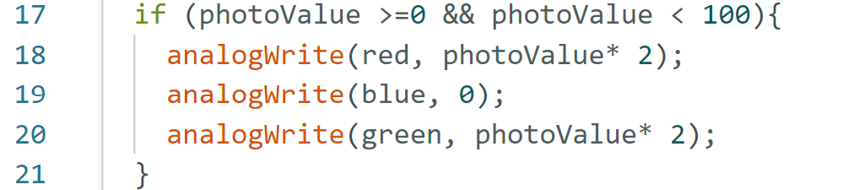
Then using if statements, we can increase the brightness of the RGB LED by changing it from yellow to red as it receives more light. The first if statement is changing the color to yellow. The analogWrite() command requires a pin number to output to and a value (determined in the previous block of code) for the duty cycle of that output signal. The higher this number, the brighter that LED (red, green, or blue).
Using an else if statement we make the RGB LED change to orange as the light increases. The final number 197 is used for those experimenting with TinkerCad as the highest number you will get is 197 so using this number allows you to get the final red color.
Using the Circuit:

Once the microcontroller is programmed and powered up, open the serial monitor. The LED will probably start as an off-white color, depending on the light intensity in the room. Look at the values coming from the sensor. Are they consistent or fluctuating greatly?
Use the flashlight on your phone and shine it on the sensor. What happens to the LED when you put the light on each one?

Exercise 3: Detecting Distance using Ultrasonic Sensors

Ultrasonic Sensors are an accurate way of detecting distance between itself and another object. In this exercise, we are going to introduce the Ultrasonic Sensor to print out how far away an object is.

Materials:
- 1 set of long red and black jumper wires
- 1 ultrasonic sensor

Building the Circuit:
- Remove USB power before tampering with the circuit
- Clear all the components from the breadboard except the lines to the power and ground buses.
- Put the ultrasonic sensor on the board, wire power to the pin labelled VCC, wire ground to the pin labelled GND.
- Wire the TRIG and ECHO pins to digital pins, 9 and 10, respectively.
- Plug in USB power and upload your code.

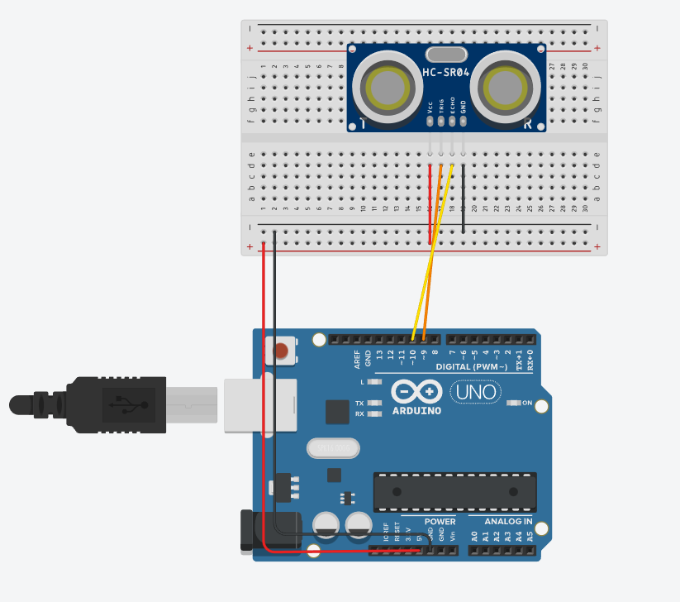

Exercise 3 Circuit

Writing the Code:

Setup the pins for trig and echo and begin the serial communication.
This starts by setting the TRIG pin to Low to make sure there is no residual signal. After the delay, it will set the TRIG pin to HIGH for 10 microseconds then back to LOW which sends a short ultrasonic pulse out of the sensor.
When the pulse bounces back to the sensor, it will be read by pulseIn function, and it will determine how long it took for the pulse to return. The duration is multiplied by 0.034 to convert the time into distance. This is because sound travels at approximately 0.034 centimeters per microsecond in a standard atmosphere. We divide it by 2 because the duration measured is for the pulse to travel to the object and back. We only need the one-way distance.
After that, the distance is printed in the serial monitor to see how far away the object that is in front of the sensor is. A small delay is added.

Challenge: Parking Sensors

Most modern-day cars come with distance sensors. These sensors are not just used for parking! Being always active, the sensors can help detect and warn you if your car is getting too close to another object while traversing through a narrow street, or when reversing into a parking space and surrounded by all 3 sides.
In this challenge, using what you have learned in the previous exercises, combine your newfound knowledge to create a parking sensor, that as we get closer to a wall, alerts us, using color. The LED should change from green, to yellow, to red as we get closer to the wall.

Requirements
- When an object is 3 feet away or more from the sensor, the RGB LED should emit a green light
- At 2 feet, a yellow light should be emitted
- At 1 foot, a red light should be finally emitted.
- Display in the Serial Monitor the distance and make it display a warning if within the red-light warning area.

Lab 2 Code Appendix (in order of appearance):

Constants (const) - A constant type is like a variable in that a value can be assigned to it, but this value cannot be changed throughout the rest of the code. It is used to store a reference value for comparison throughout the program.

map(value, fromLow, fromHigh, toLow, toHigh) - this functions scales values for you between two different ranges of numbers. For example, the ELEEGO’s ADC outputs 0-1023 for a range of 0-5 volts. If you wanted to know how many volts an ADC value of 150 corresponds to, you could use map() in the following way: map(150, 0, 1023, 0, 5)

float - Unlike an integer, this type is used to store numbers with fractions, i.e. decimal numbers.
The range of values this type can store is -3.4028235E+38 to 3.4028235E+38.

for(initialization, condition, update or increment) - The for statement is used to repeat a block of statements enclosed in curly braces. An increment counter is usually used to increment and terminate the loop. For statement is useful for any repetitive operation and is often used in combination with arrays to operate on collections of data/pins.
The initialization happens first and exactly once. Each time through the loop, the condition is tested; if it’s true, the statement block, and the increment is executed, then the condition is tested again. When the condition becomes false, the loop ends.

analogRead(pin #) - This command reads the voltage level on the given pin and converts it to a discrete value between 0 and 1023 using a device called an Analog to Digital Converter (ADC).

analogWrite(pin #, duty cycle) - This command outputs a voltage level to the specified pin. The voltage level is described by a discrete value between 0 and 255. This value is used to determine the duty cycle of the PWM signal sent to an output pin.

else if() - This statement is only used following a main if statement. If the first if statement’s argument is false, then the argument of the following else if is checked. If it is true, the code within the else if statement is executed. If it is false, then the program moves to the next else if or else statement.
Else if statements are used in a list of arguments, a programmer is only interested in taking action on one at a time. So, if one if or else if statement goes true in a list of if/else ifs, then the following else ifs are ignored by the program making for more efficient computing.

delay(time in milliseconds) - This command is used to pause a program and prevent it from updating conditions on the ELEEGO board for a specified amount of time. Note that the time entered is in milliseconds, not seconds.

delayMicroseconds() – Similar to delay, but instead of the time in milliseconds, it delays by microseconds.

pulseIn(pin, value) – This function is used to measure the length of a pulse on a given pin. It measures the time in microseconds from when the specified pin goes from LOW to HIGH (or HIGH to LOW) until it changes back. This function is particularly useful for timing applications and for working with sensors like the ultrasonic sensor.

Lab 2 Grading Rubric:
- Exercise #1 works (5 points)
- Exercise #2 works (5 points)
- Exercise #3 works (5 points)
- Challenge Exercise works (25 points)
- Comprehension Questions (10 points)
Grade distribution template (total 50 points)

